December 2, 2009

Terry L. Gustafson
Associate Dean
Arts and Sciences
4120 Smith Laboratory
174West 18th Avenue
Columbus, OH 43210

Dr. Gustafson:

I am writing in response to your letter dated November 29, 2009 regarding our request for concurrence for the proposed interdisciplinary minor in Leadership Studies. Several of the comments in your letter have been discussed by the development committee and I will summarize the results of our discussions relative to each of the numbered items in your letter.

- The purpose of the proposed minor is encompassed within the third paragraph of the Introduction section of the proposal which states that there is a growing need to provide “. . . an academic program for students to learn about leadership theories and to practice leadership skills.” A secondary purpose would be to provide structure and visibility for students interested in learning more about leadership.
With regard to the comment about student demand, we have completed a student interest survey that reveals the level of student interest in enrolling in a leadership minor as follows:

13.7% (n = 30) were extremely interested in enrolling
22.4% (n = 49) were interested in enrolling
41.6% (n = 91) were somewhat interested in enrolling
22.4% (n = 49) were not interested in enrolling

These results will be appended to the Leadership Studies minor proposal prior to submission to CAA.

- The comment regarding “truth in advertising” is well-taken and has been discussed at length. The foundation of the proposed minor clearly focuses on leadership theories, principles, and concepts. Although students will be expected to develop and practice leadership skills and abilities through learning activities incorporated within each course, the second paragraph of the proposal (Introduction section) clearly indicates that the proposed minor “should not be misconstrued as a leader certification program.” This basic premise does need to be clearly communicated to current and prospective students; however you can rest assured that I have emphasized that point in the leadership courses that I teach.

- The comment about including a required Communication course has also been discussed at length among members of the development committee. However, the decision to structure the Leadership Studies minor in its current form was based on the desire to focus on leadership theories, principles, and concepts . . . and not on experiential learning and skill development. The development committee acknowledges that communication skills and abilities are important for leadership success. However, the proposed minor places less emphasis on skill development and more on the theoretical constructs of leadership. In so doing, the decision was made not to include required coursework in Communication.

- The comment regarding the practicum experience was intriguing. The development committee suggested that the students’ home department would be the likely supervisory contact for a leadership practicum experience in the disciplinary context of the students’ interest. In addition, it was assumed that credit hour generation would accrue to the home department as well. If that is not the case, the minor Advisor Chair would be responsible to supervise the practicum experience with the underlying credit hours accruing to the departmental administrative unit housing the Leadership Studies minor.

- It is agreed that a single advisor would be beneficial to oversee the Leadership Studies minor. I have agreed to serve that role if that is agreeable with the stakeholders involved. Our department has taught undergraduate leadership courses for over 30 years and works closely with the OSU Leadership Center as evidenced by the fact that we plan to integrate its staff and programs into our unit in the near future.

Dr. Gustafson, I appreciate the review and comments that you and your colleagues in the College of Arts & Sciences have devoted to this proposal. The above responses are provided with the hope that each concern has been adequately addressed. If so, I have attached another copy of the concurrence form and request that you return a signed copy if you are in agreement. If not, please let me know and I will schedule a time to meet with you and discuss how we should proceed.

Thank you in advance for your consideration.

Respectfully,
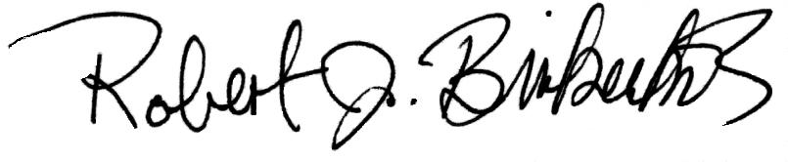
Robert J. Birkenholz
Professor of Agricultural and Extension Education

cc: Jessica Mercerhill
Donald Stenta
Jill Pfister
L.H. Newcomb

